Ten A Term – Spring 2025
Suggested Non-Fiction for Nursery

 | Title | Author
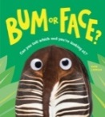 | Bum or Face ? | Kari Lavelle
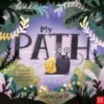 | My Path | Jana Curil
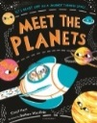 | Meet the Planets | Caryl Hart
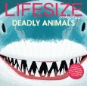 | Lifesize : Deadly Animals | Sophie Henn
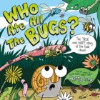 | Who Ate All the Bugs? | Matty Long
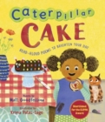 | Caterpillar Cake | Matt Goodfellow
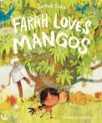 | Farah Loves Mangoes | Sarthak Sinha
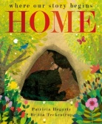 | Home | Britta Teckentrup
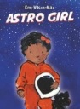 | Astro Girl | Ken Wison -Max
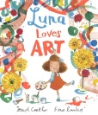 | Luna Loves Art | Joseph Coelho

