Ten A Term – Spring 2025
Suggested Non –Fiction for Reception

 | Title | Author
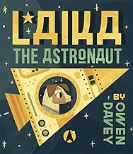 | Laika the Astronaut | Owen Davey
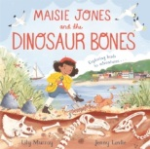 | Maisie Jones and Dinosaur Bones | Jenny Lovlie
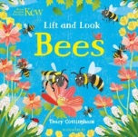 | Lift and Look:Bees | Tracy Cottingham
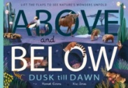 | Above and Below | Nic Jones
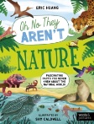 | Nature: Fascinating Facts You Never Knew | Eric Huang
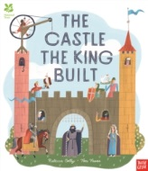 | The Castle the King Built | Tom Froese
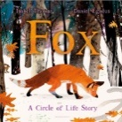 | Fox | Isabel Thomas
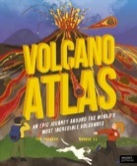 | Volcano Atlas | Tom Jackson
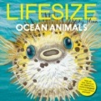 | Lifesize :Ocean Animals | Kes Gray
 | Little Kids Big Book of Pets | National Geographic

