Ten A Term –Spring 2025
Suggested Non-Fiction For Year 1
 | Title | Author
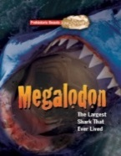 | Megalodon | Dougal Dixon
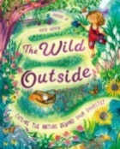 | The Wild Outside | Rachel Ip
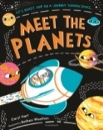 | Meet The Planets | Caryl Hart
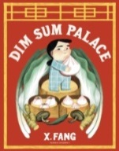 | Dim Sum Palace | X Fang
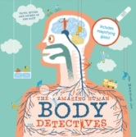 | Amazing Human Body Detective | Maggie Li
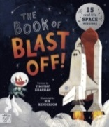 | Book of Blast Off | Timothy Knapman
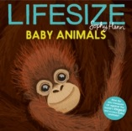 | Lifesize: Baby Animals | Sophy Henn
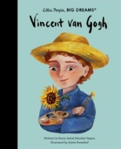 | Vincent Van Gogh | Maria Isabel Sanchez Vegara
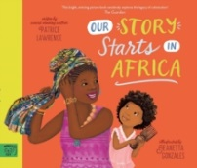 | Our Story Starts in Africa | Patrice Lawrence
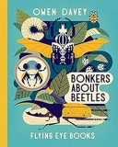 | Bonkers About Beetles | Owen Davey

