Ten A Term –Spring 2025
Suggested Non-Fiction – Year 2
 | Title | Author
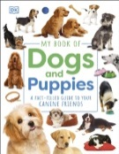 | My Book of Dogs and Kittens | DK
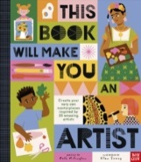 | This Book Will Make You An Artist | Ruth Millington
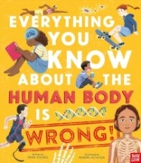 | Everything You Know About the Human Body Is Wrong | Emma Young
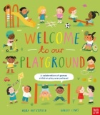 | Welcome to Our Playground | Moira Butterfield
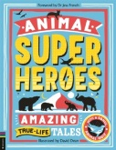 | Animal Superheroes | Camilla De La Bedoyere
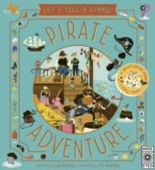 | Pirate Adventure | Lily Murray
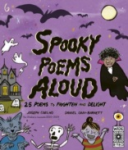 | Spooky Poems Aloud | Joseph Coelho
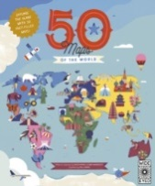 | 50 Maps of the World | Ben Handicott
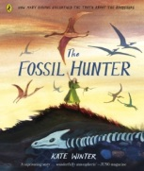 | The Fossil Hunter | Kate Winter
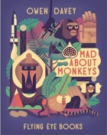 | Mad About Monkeys! | Owen Davey

