Ten A Term –Spring 2025
Suggested Non-Fiction Reads – Year 3
 | Title | Author
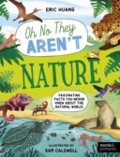 | Oh No They Aren’t : Nature | Eric Huang
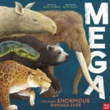 | Mega: The Most Enormous Animals Ever | Jules Howard
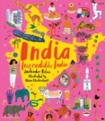 | India, Incredible India | Nina Chakrabarti
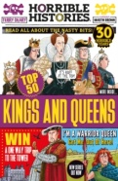 | Top 50 kings and Queens | Terry Deary
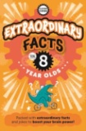 | Extraordinary Facts for 8 Year Olds | Caroline Rowlands
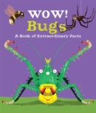 | Wow Bugs! | Camilla De La Bedoyere
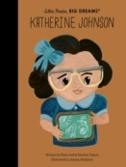 | Katherine Johnson | Maria Isabel Sanchez Vegra
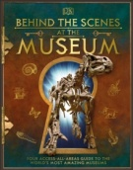 | Behind the Scenes at the Museum | DK
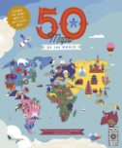 | 50 Maps of the World | Ben Handicott
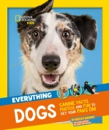 | Everything Dogs | Natural Geographic

