Ten A Term –Spring 2025
Suggested Non Fiction Reads for Year 4
 | Book | Author
 | Football Legends | David Balheimer
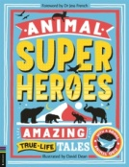 | Animal Superheroes | Camilla De La Bedoyere
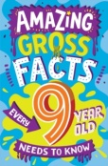 | Amazing Gross Facts | Charlotte Rowland
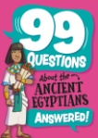 | 99 Questions about the Ancient Egyptions | Annabel Stones
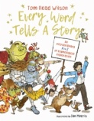 | Every Word Tells a Story | Tom Ross Wilson
.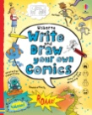 | Write and Draw Your Own Comics | Louie Stowell
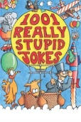 | 101 Really Silly Jokes | Mike Phillips
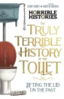 | Truly Terrible History of Toilets | Terry Deary
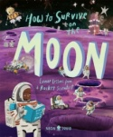 | How to Survive on the Moon | Joalda Morancey
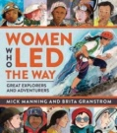 | Women Who Led the Way | Mick Manning

