Ten A Term –Autumn 2024
Suggested Reads For Year 1
 | Title | Author
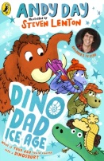 | Dino Dad : Ice Age | Andy Day
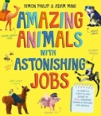 | Amazing Animals with Astonishing Jobs | Adam Ming
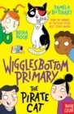 | The Pirate Cat | Pamela Burchart
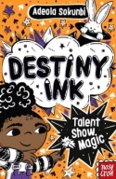 | Destiny Ink | Adeola Sokunbi
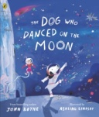 | The Dog Who Danced on the Moon | John Boyne
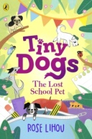 | Tiny Dogs:The Lost School Pet | Rose Lihou
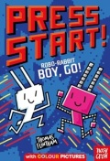 | Robo-Rabbit Boy Go! | Thomas Flintham
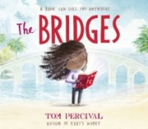 | The Bridges | Tom Percival
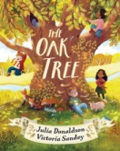 | The Oak Tree | Julia Donaldson
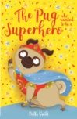 | The Pug Who Wanted to be a Superhero | Bella Swift

