Ten A Term –Autumn 2024
Suggested Reads – Year 2
 | Title | Author
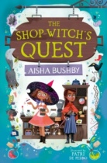 | The Shop Witch’s Quest | Aisha Busby
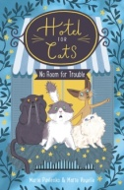 | Hotel for Cats: No Room for Trouble | Marie Pavlenko
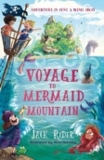 | Voyage to Mermaid Mountain | Jack Ryder
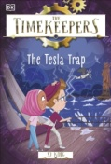 | The Timekeepers: The Tesla Trap | SJ King
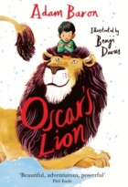 | Oscar’s Lion | Adam Baron
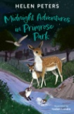 | Midnight Adventures in  Primrose Park | Helen Peters
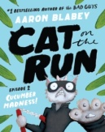 | Cat on the Run | Aaron Blabey
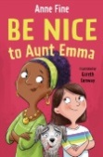 | Be Nice to Aunt Emma | Anne Fine
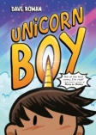 | Unicorn Boy | Dave Roman
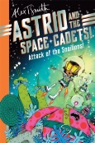 | Astrid and the Space Cadets | Alex T. Smith

