Ten A Term Autumn 2024
Suggested Reads for Year 4
 | Book | Author
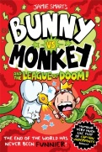 | Bunny vs Monkey: The League of Doom | Jamie Smart
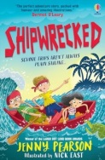 | Shipwrecked | Jenny Pearson
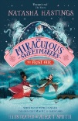 | The Miraculous Sweetmakers:  The Frost Fair | Natasha Hastings
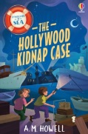 | The Hollywood Kidnap Case | A.M. Howell
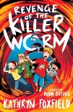 | Revenge of the Killer Worm | Kathryn Foxfield
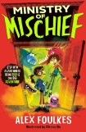 | Ministry of Mischief | Alex Foulkes
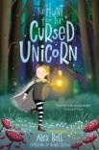 | The Hunt for the Cursed Unicorn | Alex Bell
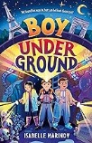 | Boy Underground | Isabelle Marinov
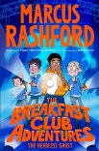 | The Breakfast Club Adventures: The Headless Ghost | Marcus Rashford
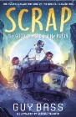 | Scrap : The Good ,The Bad and the Rusty | Guy Bass

