Ten A Term –Autumn 2024
Suggested Reads – Year 3
 | Title | Author
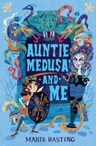 | Auntie Medusa and Me | Marie Basting
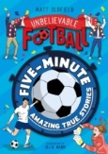 | Five –Minute Amazing True Football Stories | Matt Oldfield
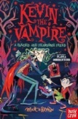 | Kevin the Vampire | Matt Brown
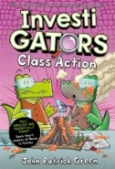 | Investigators: Class Action | John Patrick Green
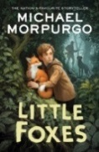 | Little Foxes | Michael Morpurgo
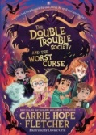 | The Double Trouble Society and the Worst Curse | Carrie Hope Fletcher
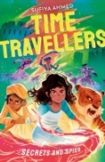 | The Time Travellers: Secrets and Spies | Sufiya Ahmed
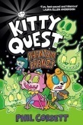 | Kitty Quest | Phil Corbett
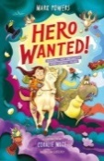 | Hero Wanted! | Mark Powers
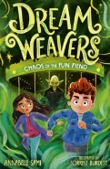 | DreamWeavers: Chaos of the Fun Fiend | Annabelle Sami

