Ten A Term –Autumn 2024
Suggested Reads for Reception

 | Title | Author
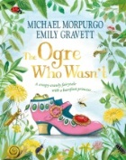 | The Ogre Who Wasn’t | Michael Morpurgo
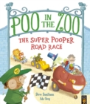 | Poo at the Zoo: The Super Pooper Road race | Steve Smallman
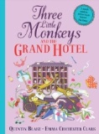 | Three Monkeys and the Grand Hotel | Quentin Blake
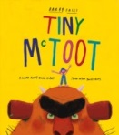 | Tiny McToot | Barry Falls
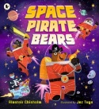 | Space Pirate Bears | Alistair Chisholm
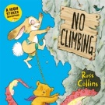 | No Climbing | Ross Collins
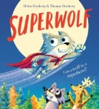 | Superwolf | Helen Doherty
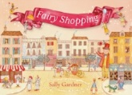 | Fairy Shopping | Sally Gardner
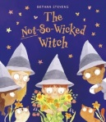 | The Not So Wicked Witch | Bethan Stevens
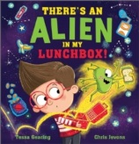 | There’s An Alien in my Lunchbox | Tessa Gearing

